Chapter 8, Problem 69.

Given the source-free circuit in Fig. 8.114, use PSpice to get i(t) for 0 < t < 20 s. Take v(0) = 30 V and i(0) = 2 A.

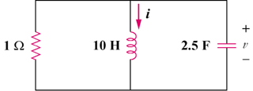

Figure 8.114
For Prob. 8.69.

